**Tips for Summarizing Research**

* It should be written in a clear and concise manner.
* It should be no more than one paragraph long.
* It should not include any new information or arguments.
* The summary should briefly describe the main points of the document.

**Steps to write a summary:**

1. Read and reread while taking notes (these can be bulleted)
2. The most common place to find the stated main idea (topic sentence) is in the first sentence of a paragraph.
3. Use the *TITLE* of the article to help with
4. The second most common place for a stated main idea is in the last sentence of a paragraph.
5. If neither the first nor final sentences, what do all the sentences have in common?
6. Do not copy phrases or sentences unless they are being used as direct quotations.
7. Express the underlying meaning of the article, but do not critique or analyze.
8. The summary should be about one third the length of the original article.

**Let’s Try! Source Title: Gun Control**

[*Gun control*](https://go.gale.com/ps/retrieve.do?resultListType=RELATED_DOCUMENT&searchType=ts&userGroupName=centralbucksouth&inPS=true&contentSegment=&prodId=OVIC&docId=GALE|PC3010999212&it=r) refers to legislation and regulations that place controls on the ownership of [firearms](https://go.gale.com/ps/retrieve.do?resultListType=RELATED_DOCUMENT&searchType=ts&userGroupName=centralbucksouth&inPS=true&contentSegment=&prodId=OVIC&docId=GALE|PC3010999212&it=r), restrict certain types of firearms, or determine where they may be carried. In the [United States](https://go.gale.com/ps/retrieve.do?resultListType=RELATED_DOCUMENT&searchType=ts&userGroupName=centralbucksouth&inPS=true&contentSegment=&prodId=OVIC&docId=GALE|PC3010999212&it=r), gun control is a highly controversial topic that engenders debate surrounding public safety, state and federal government oversight, and individual rights. Supporters of gun control seek tighter restrictions on the sale and circulation of firearms to decrease the high incidence of gun-related violence and deaths in the United States, while opponents argue they have a constitutional right to own and bear firearms.



Data from 2020 showed there were 45,222 firearm-related deaths in the United States, as reported by the US Centers for Disease Control and Prevention (CDC). Among firearm-related deaths in the United States in 2020, about 54 percent were suicides and about 43 percent were homicides. Firearm-related injuries rank in the top five causes of death for United States citizens up to age sixty-four. Assault by firearm accounts for 70 percent of nonfatal firearm-related injuries, while unintentional injury accounts for 20 percent. The vast majority of victims (86 percent) are male.



Many Americans support the [right to bear arms](https://go.gale.com/ps/retrieve.do?resultListType=RELATED_DOCUMENT&searchType=ts&userGroupName=centralbucksouth&inPS=true&contentSegment=&prodId=OVIC&docId=GALE|PC3010999212&it=r) but also believe the government has the right to regulate firearms in the interest of public safety. Though there are differences along party lines, a 2022 Gallup poll found that 66 percent of Americans believe gun control laws should be stricter, and 8 percent believe they should be less strict. Gun rights groups, such as the [National Rifle Association](https://go.gale.com/ps/retrieve.do?resultListType=RELATED_DOCUMENT&searchType=ts&userGroupName=centralbucksouth&inPS=true&contentSegment=&prodId=OVIC&docId=GALE|PC3010999212&it=r) (NRA), aim to prevent new gun control legislation and, if possible, roll back existing legislation. In the late twentieth century, the NRA wielded significant political influence at the national and state levels, especially among conservative politicians. In response, gun control organizations such as Brady, Giffords, and Everytown for Gun Safety have lobbied for legislation that better regulates gun ownership, such as requiring waiting periods, [background checks](https://go.gale.com/ps/retrieve.do?resultListType=RELATED_DOCUMENT&searchType=ts&userGroupName=centralbucksouth&inPS=true&contentSegment=&prodId=OVIC&docId=GALE|PC3010999212&it=r), gun permits, gun safety training, and restrictions on the possession of [assault weapons](https://go.gale.com/ps/retrieve.do?resultListType=RELATED_DOCUMENT&searchType=ts&userGroupName=centralbucksouth&inPS=true&contentSegment=&prodId=OVIC&docId=GALE|PC3010999212&it=r).



**Source Citation:**

"Gun Control." *Gale Opposing Viewpoints Online Collection*, Gale, 2022. *Gale In Context: Opposing Viewpoints*, link.gale.com/apps/doc/PC3010999212/OVIC?u=centralbucksouth&sid=bookmark-OVIC&xid=71d7c0a0. Accessed 2 Nov. 2023.

**What makes it:**

|  |  |  |
| --- | --- | --- |
|  |  |  |

**Practice for Writing a Summary**

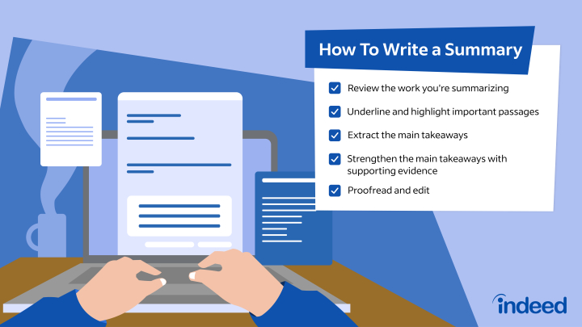

**Summary Stems:**

**Who**

**(wants to do) What?**

**When?**

**Where?**

**Why?**

Look for main ideas in your notes

Write a condensed version

Don’t get bogged down in details

Read

Reread

Take Notes

Review those notes

* **Revisit the main idea:** Make sure you read over your writing and figure out what needs to be mentioned to help drill the idea into the reader’s mind.
* **Keep it short and sweet:** You’ll want to keep things as short as possible while still offering essential information to the reader.
* **State the facts:**Revisit the facts and make sure they are clear to the reader; add your opinion if that’s what they’ve come for.
* **Smooth writing:** Make sure the summary flows as well as the rest of your text.

Let’s Try:

_________________________________________________________________________________________________________________________________________________________________________________________________________________________________________________________________________________________________________________________________________________________________________________________________________________________________________________________



Or a recent movie of choice!

**What makes it:**

|  |  |  |
| --- | --- | --- |
|  |  |  |